Report for project

Group 5: Christoffer, Herman, Andreas, Simen, Arman and Martin

USN

APP 2000

Content

Project Management 2

Team structure 2

Tasks described by group members. 3

Christoffer 3

Arman 4

Herman 4

Simen 4

Andreas 4

Martin 4

Problem statement 5

Technical approach 5

Front end 5

Back end 5

Database system 5

Design of the software 6

Wireframes 6

Component, and Deployment Diagrams 10

Results of user interface design 11

Description of program code 12

Test plan 14

Future enhancements 16

Conclusions 17

Reflections 18

Changelog 19

# Project Management

## Team structure

The groups team structure is set up by us having 1 leader, that will help, and assign tasks to the other group members. However, the leader is not the one doing the decision making, which is up to majority instead. The only power the leader of the group has is that they have a final say for split decisions if we cannot come into an agreement. The group leader will also be the Scrum master of this project.

The team structure is like this:

|  |  |
| --- | --- |
| Christoffer | Group Leader |
| Arman | Group member |
| Andreas | Group member |
| Herman | Group member |
| Simen | Group member |
| Martin | Group member |

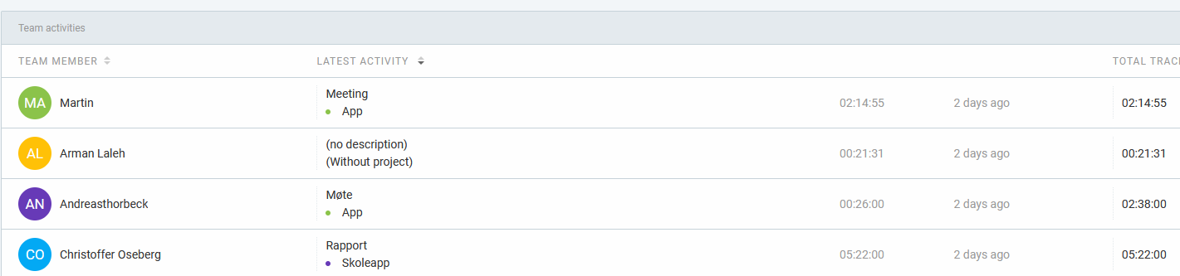To follow each members hours spent on each task we are using a program which is free called “Clockify”, this allows us to track, assign and keep watch over the group members if they are doing their work. This also helps us see if we are behind in certain areas, so that we can provide extra support where it is needed.

Here we can see different members, when they last worked were active, what type of task / other stuff they were working on etc. For example, Christoffer worked on the report for the project 2 days ago on the picture, which he worked for 5 hours and 22 minutes.

We can easily track time spent on a Task with “Clockify” by using this feature:

This will then real time track your time, and when you are done, you can click stop to stop the timer, this will then record the time taken for the project.

## Tasks described by group members.

In this section we will be describing how the different group members have been working, and what they have done to contribute to the project.

### Christoffer

|  |  |
| --- | --- |
| Base research for the architectural design of the project | What this implies is that Christoffer has been working on the architectural design of the project. He has been doing research and trying to create models based upon that. |
| Working on midterm project | Christoffer has been working on the Midterm project between the end of last year until the delivery date, trying to figure out some of the pain points, and based on feedback trying to change some of these points that we got as feedback last year. |
| Base framework both research, and coding | Since we are creating an APP, we wanted it to at least be available on Android (as it is mostly open source, and not as strict as Apple as of right now.) We had to figure out what we are going to do with both backend, and frontend.  Christoffer has then done research on Node.JS which is a backend software we can therefore use to finalize and create a HTML, CSS and JavaScript website into an APP on Android etc. This is possible because when using Node.JS we are connecting it to Cordova which will then create a www folder (website folder) on our Desktop. Which in the end will allow us to import it into an Android APP |
| Rewriting the midterm project based on feedback (which is present in the report) | As our midterm project report was not up to standard, Christoffer took it upon himself to rewrite some of the content as it was too much clutter, and it was not at all coherent. This should be fixed and will be more obvious in the final report. |
| Helping the others completing tasks, finding out about tasks etc. | Christoffer has been open to help other people if they need help with tasks and will try to find new tasks for the people that does not have anything to do as they finish off their part of the project. Christoffer will then Give tasks to the people that do not have anything to do. |
| Writing main part of the Final report | As the final report needs to be coherent, Christoffer has taken upon himself the responsibilities to write the main part, while getting help with different information from the other group members. This will in turn make it so the text is better to read as it is not written by 5 other people. |
| Use case, and Use case diagrams | Christoffer has created Use Case Diagrams (which is in this report) and Use cases to use for figuring out perhaps what a typical user would do with our product. |
| Importing the website into APP form | Christoffer is currently working on Importing a website mock-up to APP form, so that we can start the process when everything is done with the functions etc. This will also in turn make it obvious if there are any changes, we need to do last minute. |
| Creating Model diagrams | Creating both the component diagram, and deployment diagram for the design part of the project. |

### Arman

|  |  |
| --- | --- |
|  |  |

### Herman

|  |  |
| --- | --- |
|  |  |

### Simen

|  |  |
| --- | --- |
|  |  |

### Andreas

|  |  |
| --- | --- |
|  |  |

### Martin

|  |  |
| --- | --- |
|  |  |

# Problem statement

Universities struggle with students not being engaged enough therefore students lack a convenient way to express opinions, while teachers face challenges in collecting feedback. Traditional classrooms may not provide enough opportunities for interaction.

Our project aims to develop a student app that enables both students and teachers to create polls and share ideas. The app also includes an interactive map feature for campus navigation and connecting with other students. Our app seeks to foster a more dynamic and inclusive learning environment.

# Technical approach

Our APP has some different technologies used in it, but it is simple as well to explain. We are essentially turning a web-based application into APP form using Node.JS framework, and a framework called Cordova. Which allows us to turn a web-based application into app form. We have been using the technologies HTML, CSS, PHP, and JavaScript as well. However, we also have been coding in a back-end program called Node.JS, which we will explain more of later.

## Front end

For the front end of the application, we are using HTML, CSS, and JavaScript. Pretty simple, we are using HTML, as the base for our website, connected to PHP and such. We are using CSS for the looks of the website, and some animations. And at last, we are using JavaScript for both some of the animations, and features on the website.

## Back end

For backend, we will be using Node.JS for backend, which allows us as developers to use it to create server-sided applications. If we are going to explain what Node.JS is, and what its uses are, its for creating either webserver, APIs, or Applications in real time. You can also create microservices, and other backend services with it.

## Database system

For the database we are using a MySQL database which we are used to work with, and we have created it to contain different information about the user like log in, and it will also contain the polls the user created. This is so that the user can read their previous results on the polls they either created or participated in.

We will later the report show the reader how the database is set up and explain a little more about it in general. But to summarize it in short details, it will be a MySQL database, which is managed by us, which stores data like account login details. (For now, until if we eventually can integrate FEIDE login instead as a future improvement.) And Stores polls so the user can get the results later their profile page.

Other features we would have liked to add to the database is for example student news, where students are able to see useful information like school news, or any other important news for the students. (Hopefully this would be a nice feature to add later, unfortunately we couldn’t finish this feature at time because of some problems.)

# Design of the software

## Wireframes

We started off this year thinking of what we wanted the app to look like, and we created some Wireframes based on this:

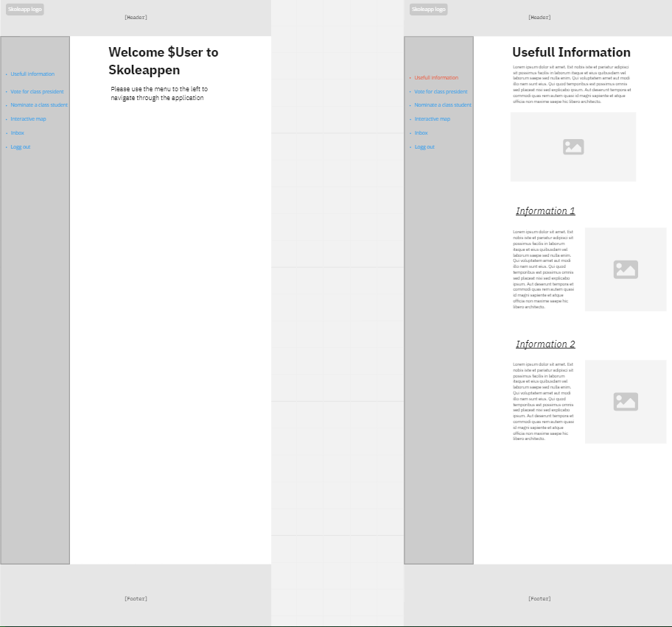

This shows the Main page, and the useful information tab, there isn’t a lot of changes there, other than some of the tabs in the hamburger menu that is not there anymore.

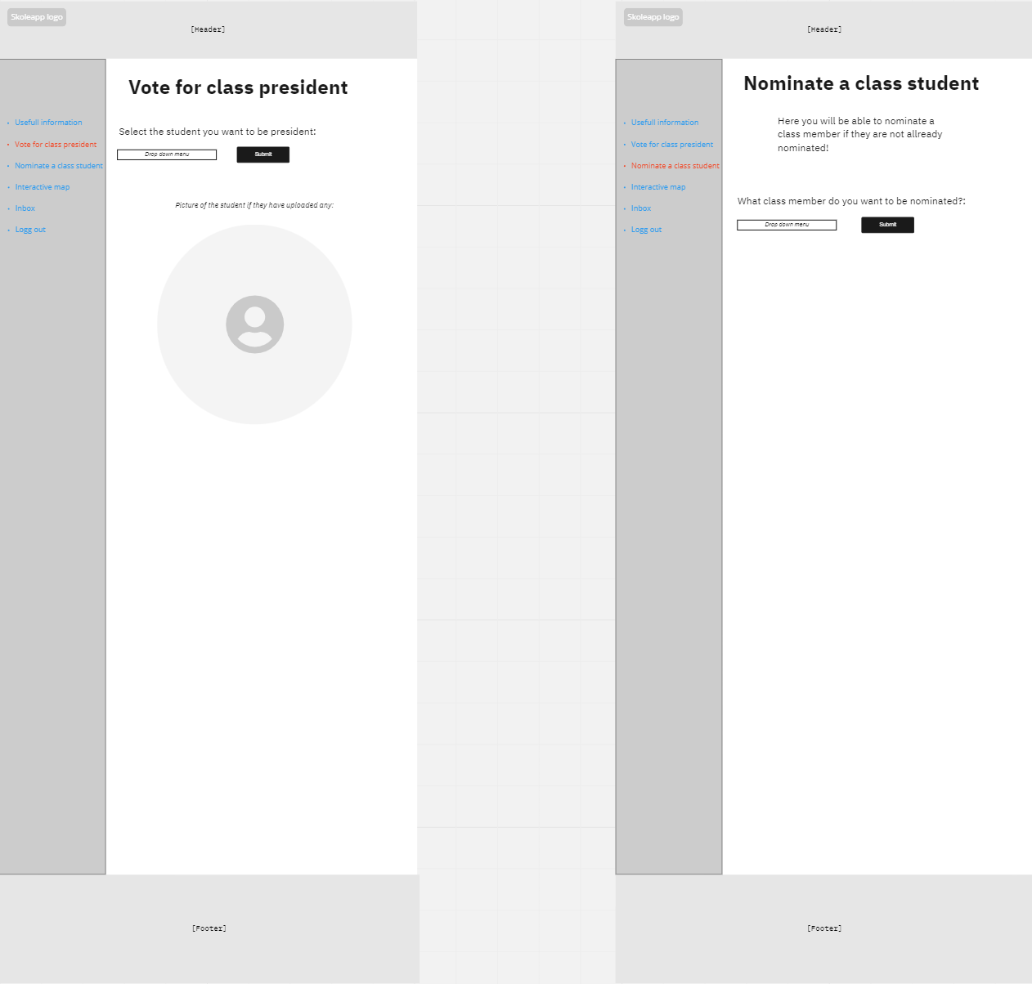

This shows what was supposed to be a class voting for president function, but we in the end decided against, instead we created a Poll system, which was suggested to us by the client. Therefore, we decided that the poll system should be access by everyone, everyone can see the results, and on my profile tab which we will be creating, they can see the results on what they decided on.

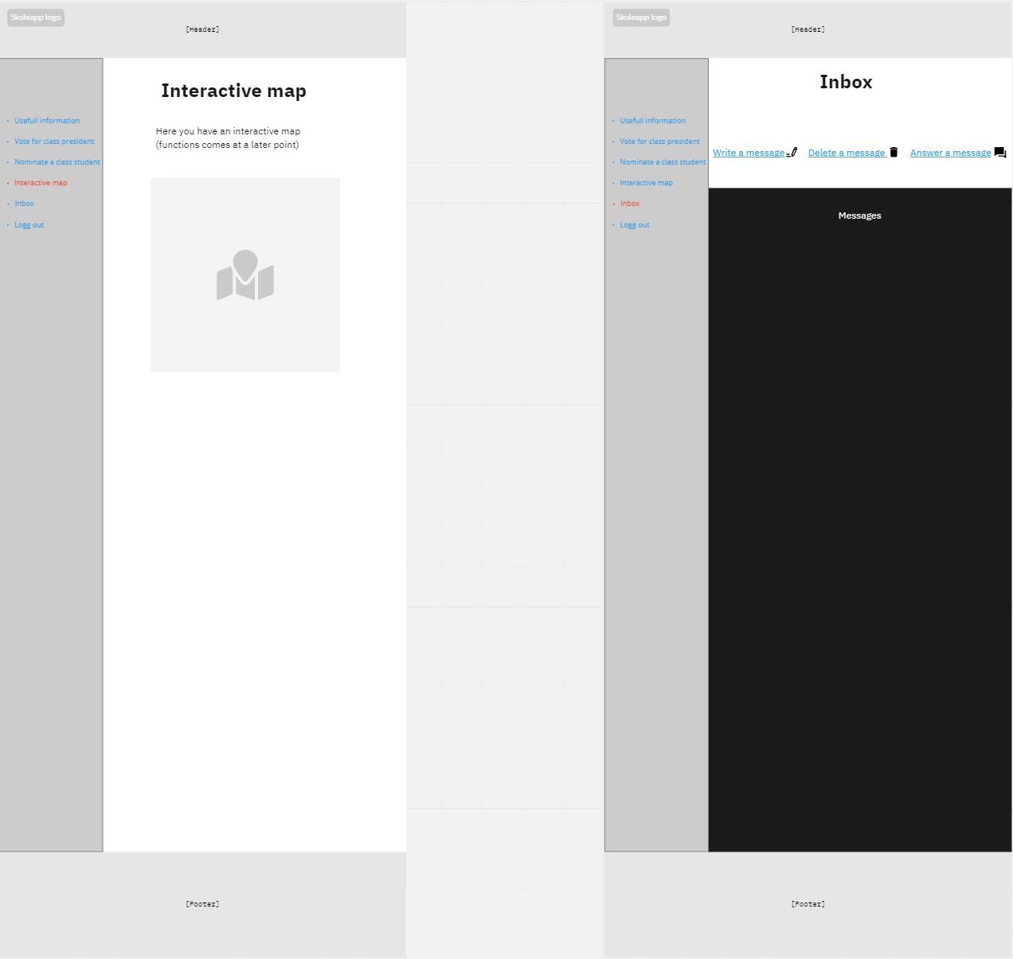

We have removed the Inbox tab (based on feedback from the Client), but the interactive map function is still there. This will use the Maze Map API to display an interactive map over Campus, that will let us use its functionality in the APP. (MazeMaps will officially be available for Campus Vestfold in between fall 2023 and the beginning of 2024, due to this we will use another Campus as the replacement for the demo.)

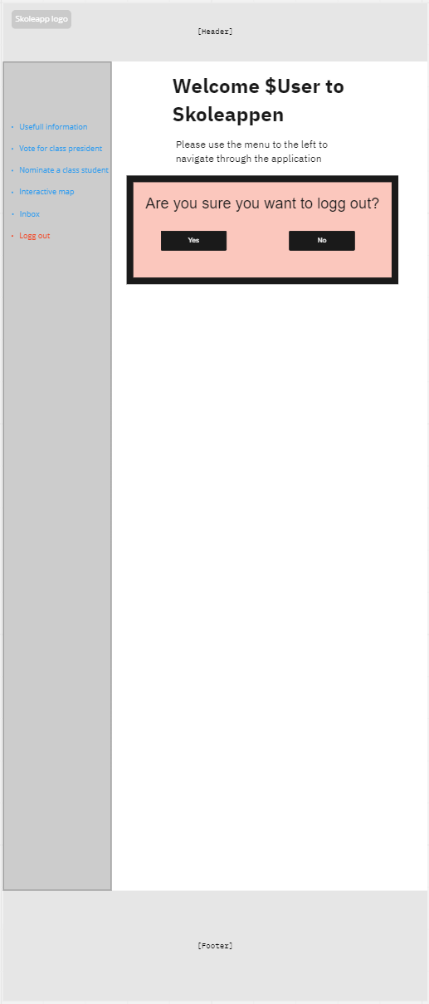

This is the last Wireframe from the design process we did last semester, this displays the option to log out, when you have been signed into the app.

Overall, we have followed the old design philosophy that we used to create this software, although, instead of a sidebar on the left, we decided to add a hamburger menu, to reduce the amount of information on your screen, which benefits the end user, especially on mobile devices.

We have also added some new features, and removed others because of a request from our client, which states that we should rather focus on a poll system, and not a “vote for class president function.” Therefore, we have also made some good changes there.

## Component, and Deployment Diagrams

# Results of user interface design

Let’s begin talking about the results of our user interface design. To obtain this result, we went through a process to gather valuable, and important data and insight onto how effective our UI design is, and how we eventually can improve upon it.

The first thing we did when we were testing the user interface design, is to find a clear goal for the design. We wanted to improve the usability, and user satisfaction which in turn will increase engagement with the application.

Second thing we did, was to find out how long our standard users take on using the app during what tasks they want to do during the usage. Like for example to create a poll for the class. We got this information by utilizing students and asking them to do certain tasks so that we can get how long it will on average take to complete the certain tasks on the application.

The results are like this:

|  |  |
| --- | --- |
| Task | Time spent |
|  |  |
|  |  |
|  |  |
|  |  |

After user testing, we will then analyse, and gather feedback from the tester so that we eventually can adjust and fix or remove stuff

# Description of program code

When it comes to our program code, we are using code that connects through multiple different languages like Node.JS, JavaScript, PHP, and HTML / CSS. This is so that we can create first a web-based application, which in turn can be converted into an app later.

**LOGIN SYSTEM** – It is a important part of our code so far as it matters a lot for privacy reasons, and so that the students can access their own polls and see their own results.

These lines of code essentially are a part of our login system for now, until we eventually would be able to integrate FEIDE into the app for easier access and login for the students and teachers. What the code describes is that it first establishes a connection with the database in MySQL, which you can see by us calling the database by creating a connection. Under the command to create connection, we will give the code the details of the host, which user is login in, password and which database we want to access.

Later in the code we will be trying to figure out the if the person has both email, and password correct for login in.

The first thing we will start with is by querying to the database. This is so we can see if the user has an account with the provided email. Therefore, right after we will create an if statement to check if the email or password provided is wrong. And after that provide an error code to the user if it’s wrong. If the email and password is correct, they will then receive a JWT (JSON Web token), meaning they will be able to log in after fulfilling all the demands from the system. (Correct email and password.)

# Test plan

To gather data for our test plan, we first must plan out how we were going to test it on the certain population of choice. First, we had to find our Test objective, which was to evaluate how usable it is, how the functions work, and ofc. The performance of the app is it passable, or are changes needed, are some of the questions we had to asks ourselves.

Second would be to figure out who our population is during this test. In this case it would be Students from different backgrounds, teachers, and the team members of this testing process.

Third thing would be to figure out some of the test scenarios that the users will go through depending on their background etc. if they are a student or teacher for example. In this case we decided to take some of the use cases, and created some scenarios based upon those.

We have written some scenarios which we may create use cases for, and some explanation why we want to test them out:

User account management:

* Creating and login into an existent student account
  + A little bit of the same as user account management, but this is to test if the user can create and login to an already created user in the system.
* Update profile information
  + This is meant to test if the user can update their information.
* Change settings, and preferences.
  + A little bit of the same to test if you can change different settings, and preferences of your profile.

Participating, and creating polls:

* As a student or a teacher, test out to create polls.
  + This is so we can test out if the poll function works for students / teachers.
* As a student or a teacher, test out if you can participate in the created polls.
  + This is so we can test out if students / teachers are able to test out if they can join the different polls created by either a student or a teacher.
* View and analyse the polls created and completed by the students / teachers.
  + Really important for when testing to see if teachers / students can see the results of the poll after they have completed or someone else have completed their polls, so they can analyse the data required for the purpose of why they created the poll.

Interactive map:

* Navigation around Campus
  + This is so we can test out if the students can navigate themselves around using the map as a feature.
* Use the interactive map to figure out what is the shortest route to their destination on the campus.
  + This is to test the functions accuracy and figure out if it is effective as a feature.

For the fourth phase of the test plan, we would start to execute the test on our population.

* We will start by doing some individual tests with each participant of the population. Which we will by then provide some clear instructions and guidance on how they are going to execute the test.
* After the test we will ask the participants about their opinion about the test, and eventually they’re after thoughts about the software they are testing. We will by then comment, and document any thoughts given.

# Future enhancements

There are some future enhancements that we probably would have wanted to do, but we did not have time to during this timeframe which is:

* Integration of Feide login into the app, so that everyone already has a User they can use on our APP, instead of them having to create one.
* Integrate the webapplication into app form so that students can access it by using google playstore, and apple Appstore.
* Integrate the correct MAP into the app, so that students can start using the app for the correct campus.

# Conclusions

# Reflections

|  |  |
| --- | --- |
| Name | Reflection |
| Christoffer | From my perspective, I’ve handled a lot of the responsibilities that the leader of a project should have and done a lot of the writing.  I would say leading a project is really tiring, as it is at times difficult to find something to do for everyone at any point in the project. We’ve had cases where we’ve had 1 or 2 people without work at the start because of the tasks provided was finished etc. Therefore, a lot of my time has also been to see if everyone has something to do, and no one is left out of the project.  When it comes to the design part of the project, I would say it was a bit difficult to figure out where to start as we didn’t have any foundation for our project, so we had to do design everything by scratch instead.  And since we worked on a free choice project instead of a already picked one, we had a lot of freedom to pick what we wanted to do, and use our own ideas for that.  We settled with a student app since we thought we maybe able to create an app perhaps students and teachers would like to use.  But the development has been difficult at times, since we are under a heavy time constraint, we couldn’t finish all the features which was planned before the exam delivery date which is unfortunate. |
|  |  |
|  |  |
|  |  |
|  |  |
|  |  |

# Changelog

* Removed the Inbox feature.
* Changed the Vote for Class president feature to a Poll system. (Which everyone can benefit from, instead of just a single class.
* Had to rely on a backup School for the interactive map, as it isn’t functional for the school we intended to use.